Dec. 21, 2022 VMCC Equity Committee Meeting Notes

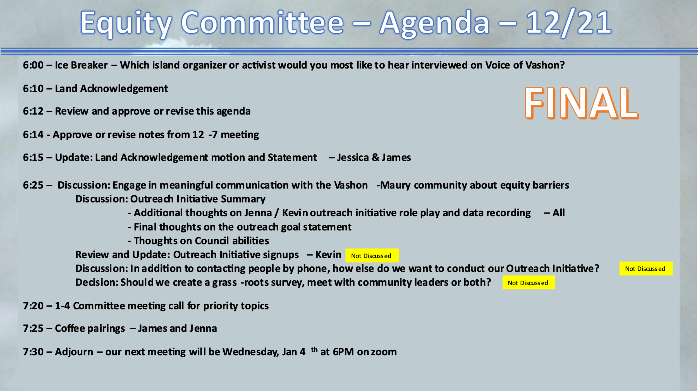

Present: Kevin Jones, James Rickard, Jenna Riggs, Deborah Anderson, Jess Anakar, Art Chippendale, Linda Fox, Terry Sullivan

The meeting convened at 6:05 pm with Ice Breaker.

The land acknowledgement was read by Kevin.

Approve/revise notes from 12/7: Approved and ready to be published on the VMCC website.

Update: Land Acknowledgement motion latest status – James/Jessica A
Next meeting: Saturday Jan. 7, 1-4pm, at the Land Trust building — next public meeting. They will be sharing the outcomes of the previous meetings, talking about how to incorporate actions. Will be advertised in the Beachcomber, as well as other channels. The final text after this community input will be delivered to the VMCC Board Thursday Jan, 12, giving the board time to review the statement(s) before the January full council meeting.

The latest recommendation is to create 5 different options for the monthly reader. The strategy offers the reader more ownership, allows for the statements to evolve, and celebrates diversity in thought and action — democracy at work.

Discussion: Engage in meaningful communication with the Vashon-Maury community about equity barriers:
Outreach Initiative Role Play Feedback (last meeting - Jenna & Kevin)
- introducing scribe/interviewer (pairs going out?)
  - From prior meetings, we are planning to team up to interview individuals and organization leaders
- interview is dense, do we send out questions ahead of time to make it more efficient?
  - From prior meetings, we decided to send an information package to interviewees prior to meeting with them.
- report whether person is a volunteer or in an official position
- training on how to record answers will be important
  - Both online and “pen and paper” options were discussed
- Action Kevin: send Art information about the Outreach Initiative Survey – Done 12/27/22
- Sector questions – are they set up to gather as much info as we are hoping for? Is “sector” the best word, could another word or phrase be more trustable in a narrative way (not clinical)? Could it go somewhere else in the order of the survey, earlier?

Discussion, Tools for us: Outreach Initiative Goal Statement
See meeting slide notes for latest wordsmithing. Art volunteered to give options to tweak the last sentence.

Discussion, Tools for us: Thoughts on Council abilities
See meeting slide notes for latest list.

Coffee pairings: James and Jenna

Meeting adjourned: 7:35 pm

Next meeting January 4, 2023 — 6:00 pm

