Jan. 18, 2023 VMCC Equity Committee Meeting Notes

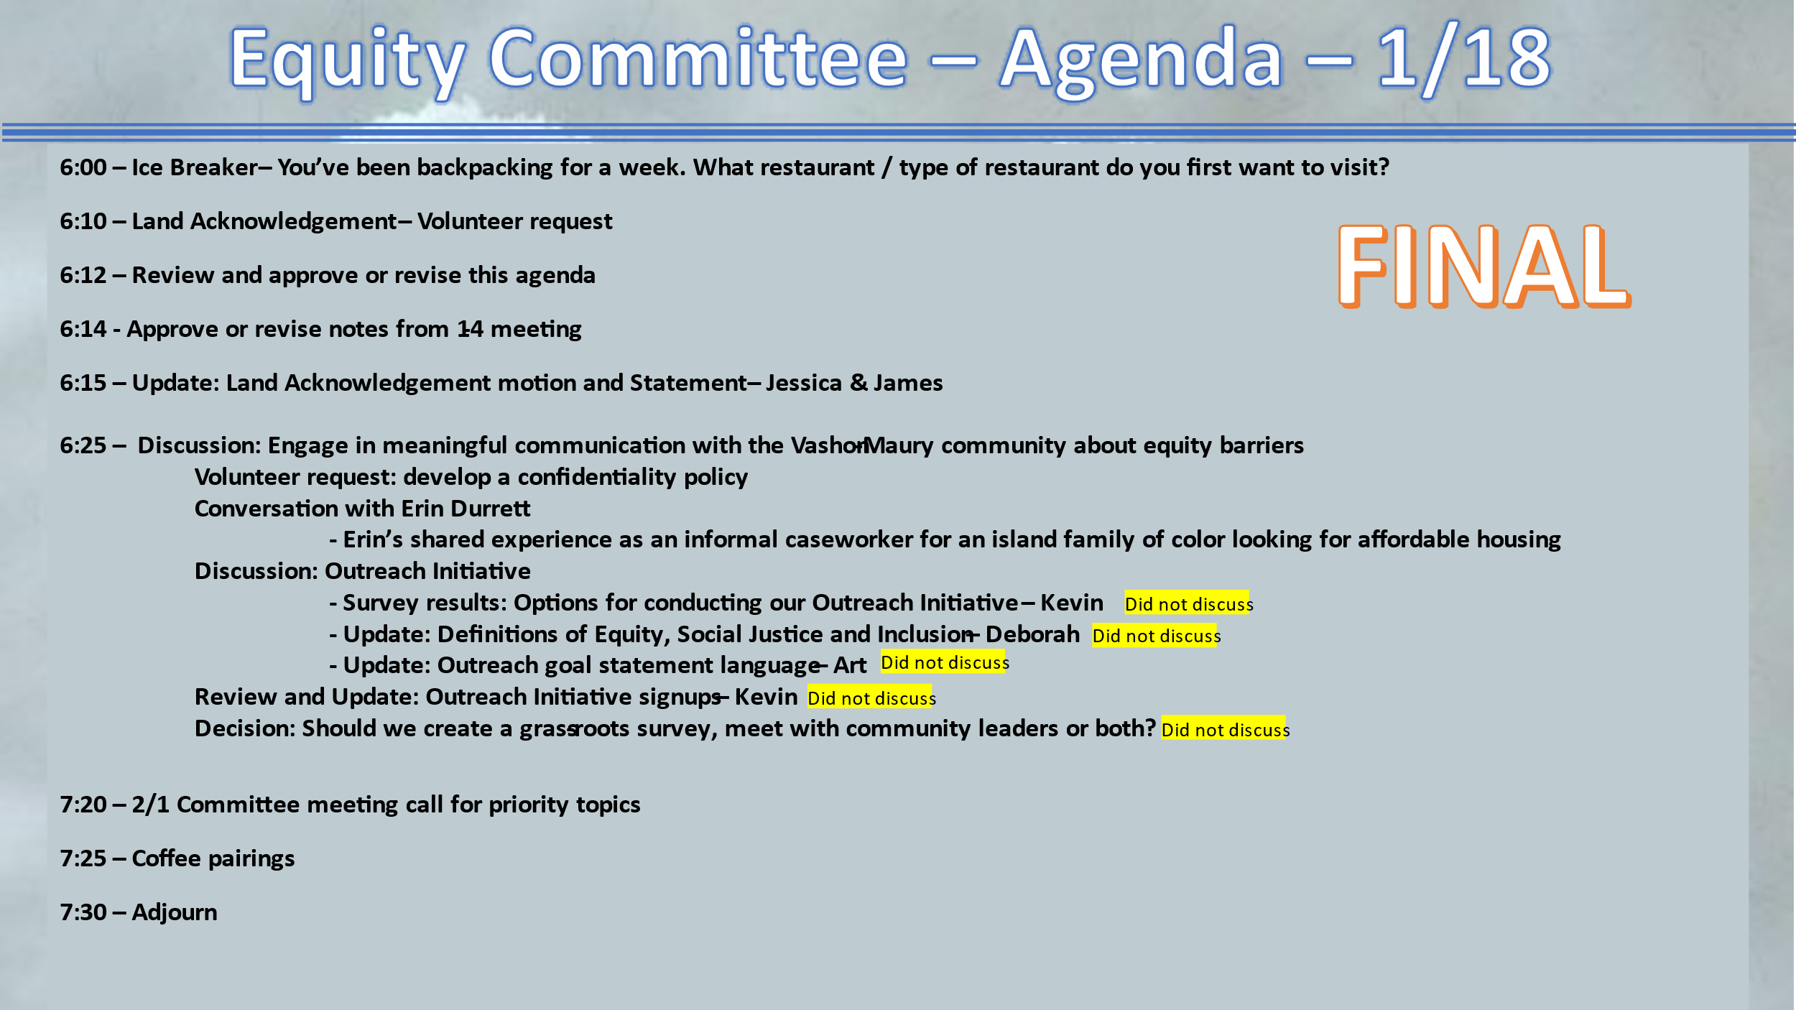

Present: Kevin Jones, Jenna Riggs, Jessica Anakar, Linda Fox, James Rickard, Allison Trundle, Terry Sullivan, Deborah Anderson, Yvonne Kuperberg, Jessica Lisovsky, Erin Durrett, Suzanne Moore, Hunter Davis, Art Chippendale

The meeting convened at 6:06 pm with Ice Breaker.

The land acknowledgement was read by Suzanne.

Approve/revise tonight's agenda:
Approved.

Approve/revise notes from 1/4/23:
Approved and ready to be published on the VMCC website.

Update: Land Acknowledgement motion latest status – James/Jessica A
Updates on last in-person meeting, they will be presenting 5 land acknowledgements at the next board meeting. We are encouraged to write to the board members to ask them to approve the language for all 5, as written.
James/Jessica will create a short paragraph for us to customize and send back to Jessica to compile for the board.

Discussion: Engage in meaningful communication with the Vashon-Maury community about equity barriers

Volunteer request: Develop a confidentiality statement
Action—Allison will take this on

Conversation with Erin Durrett about specific equity barriers and challenges to securing housing on the island, finding honorable livelihoods, participating in advocacy/civic opportunities and more. Group discussion around white privilege, classicism and how we can try to affect change.

Discussion outreach Initiative

Expect an email before Feb. 1 from Deborah with the compilation of definitions

Coffee pairings: Terry/ Allison, James/ Deborah, Terry/ Deborah

Meeting adjourned: 7:35 pm

Next meeting February 1, 2023 — 6:00 pm

