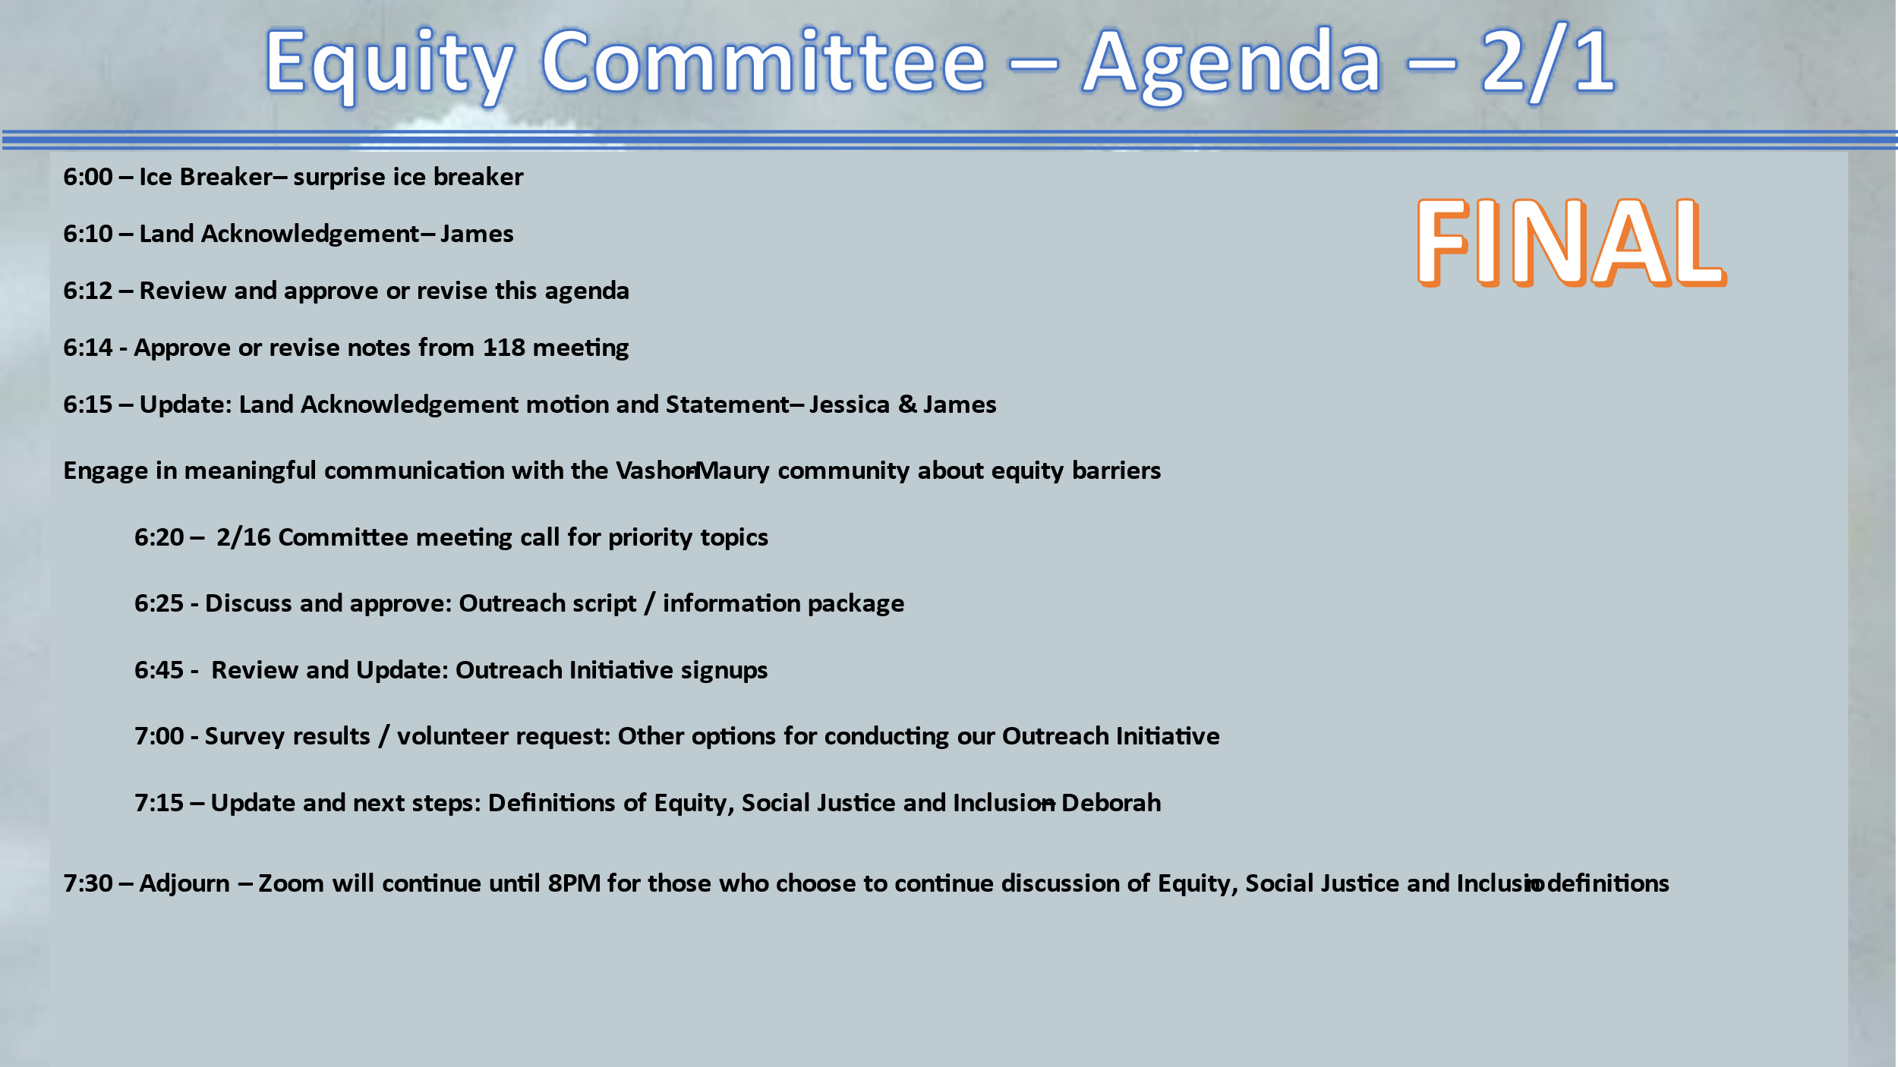

FEB. 1, 2023 VMCC Equity Committee Meeting Notes

Present: Kevin Jones, Jenna Riggs, Linda Fox, James Rickard, Allison Trundle, Terry Sullivan, Deborah Anderson, Yvonne Kuperberg, Art Chippendale, Kathleen Fitch, Diane Emerson, Jessica Lisovsky.

The meeting convened at 6:03 pm with Ice Breaker.

The land acknowledgement was read by James Rickard.

Approve/revise tonight's agenda:
Approved.

Approve/revise notes from 1/18/23:
Approved and ready to be published on the VMCC website.

Update: Land Acknowledgement motion latest status – James

Language of Land Acknowledgement will be discussed at VMCC Board meeting on Feb. 2, 2023.

Discuss and approve: Outreach Script/Information Package

1. Is there something in the script or outreach package that is not in line with what we want to achieve?
- After some clarification, the outreach product was in line with our goals.

2. Any suggestions for improvements?
- Put in "Follow-up needed."
- Add page numbers.

3. How to record and collate results?
- Survey Monkey has been used for this in the past.
- Google docs also works and we already have the survey set up as a Google survey.

Review and Update Outreach Initiative Signups: Filled in more of the grid with names of committee members willing to speak with designated community members. Also added new organizations to contact.
- Some discussion around how to have more input than just the contact person, i.e., survey questions could be shared with the organization, a summarized version (half-sheet) for the organizations to distribute in-house.

Survey Results/Volunteer Request: Other Options for conducting our Outreach
- Suggestion: Wait until we collate the results of our individual meetings before discussing the other avenues (tabling, community meetings, media)

Update & Next Steps: Definitions of Equity, Justice & Inclusion - Deborah

Deborah led discussion of definitions she gathered from committee members to highlight the crucial terminology the group could coalesce around.

Coffee pairings: none this week

Meeting adjourned: 7:42 pm

Next meeting: February 15, 2023 — 6:00 pm

