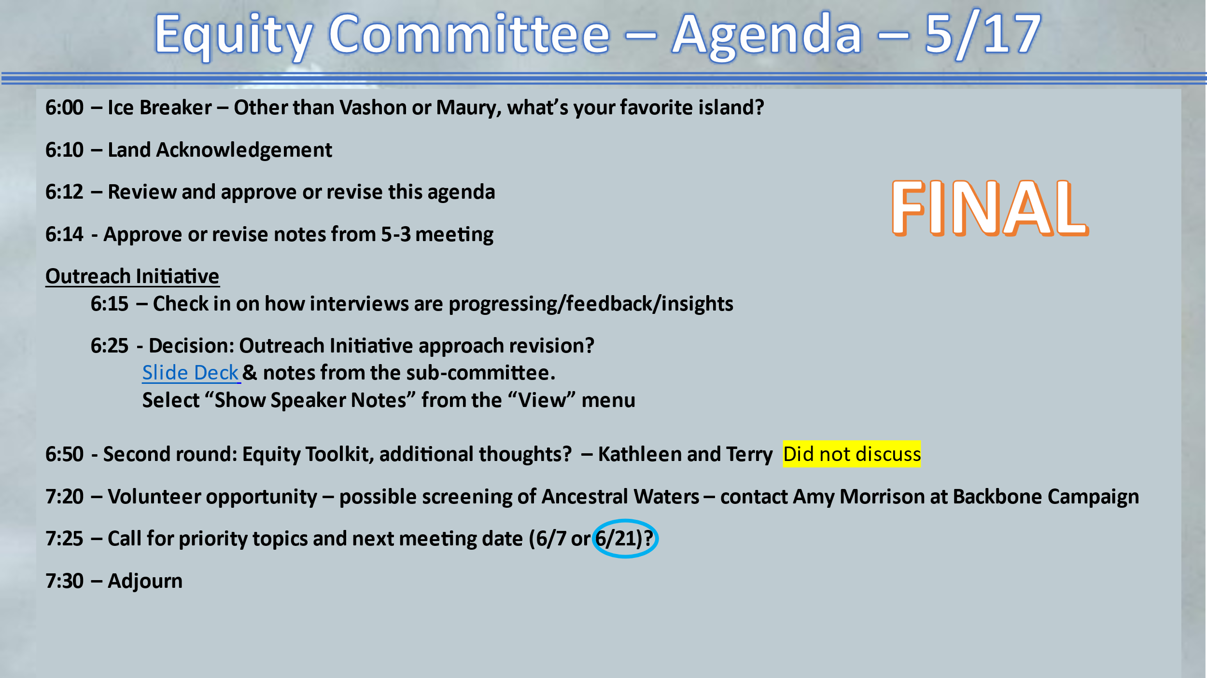

May 3, 2023 VMCC Equity Committee Meeting Notes

Present: Kevin J., Jessica A., Hunter D., Jenna R, Kathleen F., Milla A., Yve Susskind, Terry S., Deborah A., James R., Yvonne K., Allison T.

The meeting convened at 6:00 pm with Ice Breaker.

The land acknowledgement was read by Kevin Jones.

Approve/revise tonight's agenda:
Altered to hear first from Yve, then check in on interviews. We may hear from Kathleen and Terry next meeting.

Approve/revise notes from 5/3/23:
Approved without objection and ready to be published on the VMCC website.

Outreach Initiative
Follow up/summarization by Yve from her presentation last meeting. (See slides link). https://docs.google.com/document/d/10jBRQT-J2WaDo_y5gFWWcUtYKNskModi24DTo1il7Ik/edit?usp=sharing

Summary: Working with three different strategies and possible next steps for each strategy.
Discussion: In addition to what we are doing now, do we want to modify what we are doing by embracing any of the strategies and their next steps. How can we create the relationships we need to, without adding more work to board members, who are already stretched thin time-wise (They are actively recruiting more board members to grow capacity).

Recommended three prong approach
Broad overview –
- add questions into our protocol, tweak language
- potuck/sharing info/learning from the board members (how can we support you, how are the sectors working, sharing stories that we are collecting)
- Emergency fund — interest, but after our outreach. Focus on unsilo-ing and working collaboratively with other groups.

Yve’s more specific summary:
1. Add a couple of groups of questions to the current interviews:
(a) Liaison questions
• Have you been approached by a CC liaison?
• If so, how did that go, What was your experience like?
• What has resulted so far - Do they have greater visibility, does the community understand their issues, is the CC facilitating action that you want on those issues?

(b) What support do people actually want?
• What are your greatest concerns, needs, and goals right now?
• What are you already doing to represent your own issues and take action?
• How can the CC be in allegiance with what you are trying to do?

2. Potluck with the board:
• Share personal stories about fairness and feeling of belonging
• Share what you’re hearing in the interviews
• Appreciative inquiry/motivational interview-style discussion to surface and amplify what’s working well with the liaison approach

- Look into an emergency action fund (since CC mission is advocacy, it could be an emergency advocacy fund)

Volunteer Opportunity
Help with putting on a screening of “Ancestral Waters” – contact Amy at Backbone

Decision on next meeting date: June 21
Unanimous for June 21

Suggested topics for next meeting:
- How is our outreach going?
- “Ouch,” “Roses and Thorns” and “Don’t yuck my yum” (Kevin)
- Setting up coffees with board members

Vote on implementing changes to our outreach documents before Kevin leaves (with Yve’s help)
Y: 9
N: 0

Meeting adjourned: 7:35 pm

