Nov 2, 2022 VMCC Equity Committee Notes

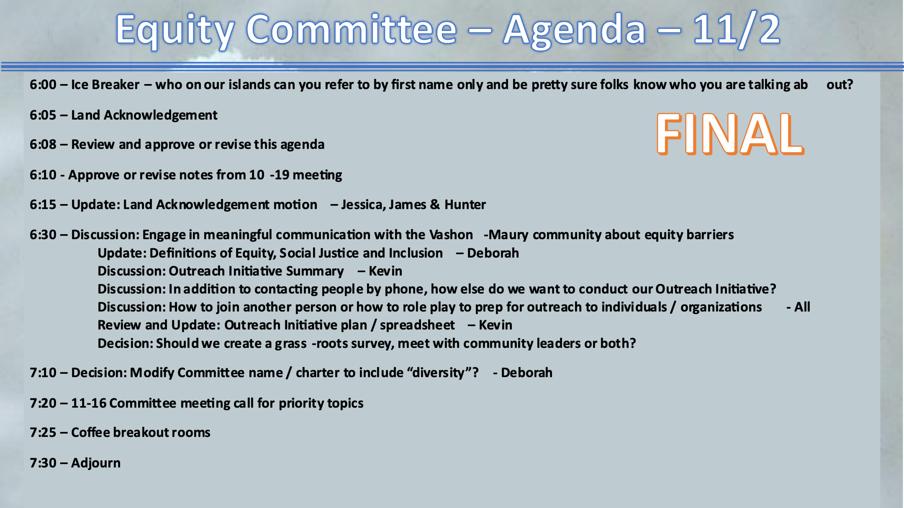

Present: Kevin Jones, James Rickard, Allison Trundle, Hunter Davis, Deborah Anderson, Kathleen Fitch, Yvonne Kuperberg, Jessica Lisovsky

The meeting convened at 6:08 pm with an icebreaker.

The Land Acknowledgement (LA)was read by Kevin. (A suggestion was made that we all should have an opportunity to say what a LA means to each of us. James assured us this would be on the agenda for the 3 community meetings beginning later this month.)

Notes from 10/19 approved and ready to be published on the VMCC website.

Update: James presented the latest information regarding the series of meetings to discuss the LA. First, the Board needs to approve the wording of the outreach communication before it's sent out.

Proposed meetings are:
- Thursday, November 14th at 6PM (Zoom)
- Tuesday, November 29th at 6PM (Zoom)
- Tuesday, December 6th at 6PM (Zoom)

On 11/21, the whole Council will vote on whether to have a Land Acknowledgement.

Discussion:

• Definitions of Equity, Social Justice and Inclusion — Deborah
See “2022-10-19 VMICC EC Slide Notes.pptx”

Deborah read 3 of the 4 definitions she has received so far. She requests that we each send her our own definitions so that she can create a single definition based on our individual, personal input.

• Outreach Initiative Summary – Kevin
The discussion centered on specifics: how will these meeting actually play out.

It may be helpful to be guided by our goals:

1. What are the barriers to justice, equity and inclusion that these organizations/groups face?

It was pointed out that it may take more than one meeting to get folks to be able to verbalize these concepts and even more difficult for them to see their own organizations thru an equity lens.

It was also suggested that we do some practice before we make our initial contacts and that we go in pairs.

2. What can the new VMCC with 501-C4 status do to help organizations communicate their issues and complaints to our local government agencies--County and State.

Question: Is the Committee open to changing our name? Deborah proposed: Justice, Equity, Diversity & Inclusion (JEDI) and gave her rationale for the change.

Reasons:
- It would align us with other similar groups around the region.
- As such, we may be in a stronger position to apply for grants for such things as a Spanish/ASL interpreter to be present at Council meetings.

Coffee meetups assigned

More considerations on topics for next meeting:

- Deborah requested more time for definitions.
- Kevin will outline the new VMCC powers under the 501-C4.

Meeting adjourned 7:35 pm.

Next meeting November 16, 6:00 pm

