Dec. 7, 2022 VMCC Equity Committee Meeting Notes

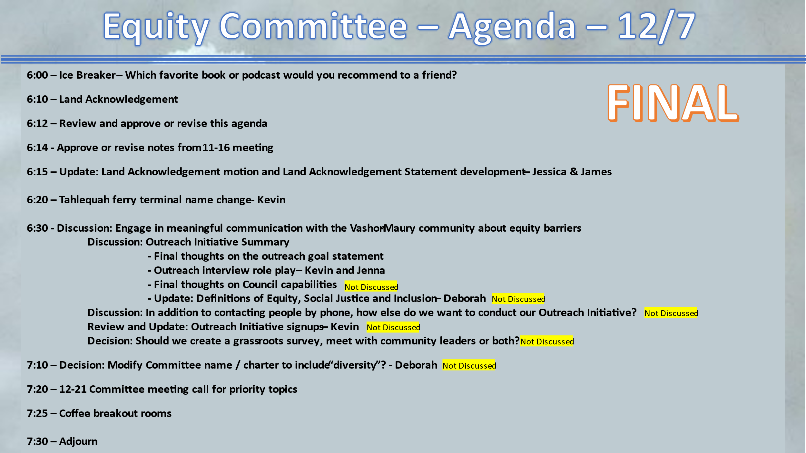

Present: Kevin Jones, James Rickard, Jenna Riggs, Kathleen Fitch, Allison Trundle, Deborah Anderson, Yvonne Kuperberg, Hunter Davis, Diane Emerson (VMCC Board President), Jess Lisovsky

The meeting convened at 6:09 pm with Ice Breaker.

The land acknowledgement was read by Kevin.

Approve/revise notes from 11/16: Approved and ready to be published on the VMCC website.

Update: Land Acknowledgement motion latest status - James
The first two zoom meetings have taken place — James informed the committee that the final meeting will be an in-person meeting in January. The final text after community input will be delivered to the VMCC Board in early 2023.

Tahlequah Ferry Dock name change
Kevin outlined the process as told to him by the WA Transportation Committee spokesperson. The state will confer with the Puyallup Tribe first. Later, the public--Vashon/Maury included--will have a chance to comment.
- Diane E. suggested that our Equity Committee could be of assistance.
- Deborah A. suggested that Indigenous islanders be involved.
- James volunteered as the Tahlequah focal for the Committee and Kathleen volunteered to participate.

Discussion: Engage in meaningful communication with the Vashon-Maury community about equity barriers:
- Outreach Initiative Role Play - Jenna & Kevin
Kevin interviewed Jenna in her role as Lead of the Vashon Immigrant & Refugee Rights work group using the outreach initiative questions developed by the committee to initiate discussion between the VMCC and the community around the issues of Inclusion, Social Justice and Equity.

Coffee pairings: Allison / Kevin; Hunter / Jenna; Deborah / James

Meeting adjourned: 7:35 pm

Next meeting December 21, 6:00 pm

